

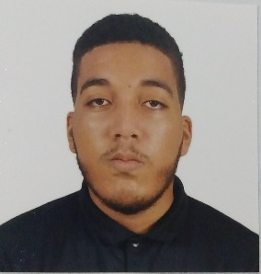

Reimys Jeremias

Pincel Santana

Los Mina, Santo Domingo Este Rep. Dom.

(809) 497 0746

Jeremias2007ps@gmail.com

**OBJECTIVE**

I stand out for my high performance in analysis and hurried situations. I am a Creative, Respectful, Intelligent, Sociable, and Companion person. I want to have the most

Real possible about what the work area is and To be able to fulfill each of the tasks and activities that I am assigned.

# Education



## 6th year of Secondary | Virgen de la Altagracia Polytechnic

2022 - CURRENT

Final Degree Student in Computer Application Development and Administration

## English – English Classes | Infotep

2023

## Battery – Battery Classes | First Bethania Evangelical Church

2023

## JavaScript – Curso online| Aprende.Org

2024

# Aptitudes and Skills



* Sociable
* Good thinking

analytic

* Good teamwork

# Experience

* Canva Management
* Handling Microsoft Office
* Average English proficiency
* Knowledge of (HTML, CSS,PHP,JS,Python,Sql,PhpMyAdmin)
* Administrative Assistant – Ferreteria Ámbar
* Upholstery Assistant – Upholstery Master

# PERSONAL REFERENCES

* Ronny pincel Contact: 829-821-8879
* Eridania santana Contact: 809-836-7758
* Anyelo Nuñez Contact: 809-617-9607